HW3_Q.10 (EE576)

Design and Simulation Problem

Instructor: Dr. Subhanshu Gupta

By: Mohammad Chahardori

ID:11632753

October 2018

In fig.1 the basic schematic of the circuit has been shown.
Fig.1. Schematic of the circuit

According to the required specification of the amplifier in the problem 10, the minimum low frequency gain of the amplifier is 10 dB which is about 3.2. To satisfy this gain, we assume the overall gain is 3.5. On the other hand, according to the circuit structure the amplifier gain in low frequency is:
(1)
The other small signal parameters that we have to satisfy is the unity gain band width ( ). The amplifier circuit shows two poles at node A (Drain of) and output node (). The values of these two poles are as bellow:
(2)

To determine the dominant pole, we have to consider the resistance and the capacitance which make these two poles. Although the resistance of node A is higher than output node, the output capacitance is larger than the capacitance seen from node A. So it would be hard to find the dominant pole by inspection, however since the output capacitance of 1Pf is really big, it seems that it would not be easy to send the output pole to frequency higher than by considering high value for . In fact, to increase the value of , we need to increase the bias current of M2 which is not possible because of the required output swing which would be a function of bias condition of M2 transistor. I will discuss more about this problem when I design the circuit to have the required swing.
Now, to have the required , I consider the output pole as the dominant pole. In this case we should pick the size of M1 and M2 such that the summation of + doesn’t exceed the borderline values of capacitor at node A. In fact to make sure that our assumption about dominant pole is correct we need to put the pole of node A in higher frequency than . In this case, we have:
(3)

According to the values of parasitic capacitors in 0.13um CMOS technology for usual sizing of M1 and M2 the parasitic capacitors would be less than 1PF which satisfy the above equation. But, it is necessary to check the parasitic capacitors after determination of M1 and M2 sizing.
Now it is easy to find the value of due to required . To find the value we can use the relation between Gain, dominant pole and . That is,
(4)

We have to considered to make sure that is achievable after simulation of the circuit.
The third specification of the amplifier which should be satisfied by the designers is the swing at the amplifier output. According to the problem.10 the amplifier should have 0.4V peak to peak voltage swing at the output. That means the output voltage should be able to vary around its bias voltage without forcing any of the 3 existing transistors to enter linear or cut-off regions. So it is important to set properly the output DC bias voltage. To find the proper DC bias voltage, first we should know the output voltage range that keeps all transistors in saturation region. This range can be calculated by determination of saturation region for each transistor as bellow:
(5)
The maximum voltage level is limited by M2 and the output bias voltage of the first stage of the amplifier that is the drain of M1. In fact, increase in output voltage can push the M2 transistor to linear or even cut-off region. Since the bias current of M2 is produced my M3 as a current source, the cut-off region for M2 is not critical here. From the circuit, it is seen that the limitation exposed by M2 when M1 entering to cut-off region and output voltage of the first stage goes up to VDD is much severe that linear region of M2 and it occurs sooner than the time M2 goes to linear region. Considering the cut-off condition of M1, we have:
(6)
It is worth to consider that the value of is larger than because of the big voltage difference between source to bulk voltage of M2 when M2 enters cut-off region and should be calculated from the formula.
Based on above calculation in which the minimum and maximum possible voltage at the amplifier output has been derived, we expect that the maximum possible swing at the output of the amplifier is:
(7)
As a result, to have the maximum symmetrical voltage swing at the output, the best output DC voltage should be close to:
(8)

Now, using equation (1) to (8) and considering the parameters of the transistors which have been extracted from simulation of an NMOS transistor in 0.13um CMOS technology and are shown in Table.1 we would be able to determine the sizing of transistors and bias voltages of the circuit to satisfy all the requirements of the circuit.

Table.1. Transistor Parameters
Parameter | Value
 | 350
 | 0.38 V
 | 0.5
 | 0.45

To start calculation of the transistor W and L based on the achieved values for gm we can consider a reasonable value for overdrive voltage of output transistors. We start with 0.2V voltage overdrive because it is far from the subthreshold region and also it is not too large so it would not limit the swing of the amplifier.
Considering for M2 andfor M3 based on equation(8) for the optimum value of output DC voltage to have maximum symmetrical swing at the output, we have:
(9)
In equation (9) we have considered the value of instead of since it has changed because of body effect. The value of is achieved by solving equation(8) and the value of Vth from equation (10) together and also by doing a simple simulation to achieve it.
(10)
Now according to the value of we can calculate the current of as follow:
(11)

In this case, the DC voltage of the first stage output would be:
(12)
Now based on the value of which is obtained from equation (1) we have:
(13)
For transistor M2, since we considered and based on the calculated from equation (4) we have:

For the overdrive voltage of the M3 transistor we can consider 0.1V, for more swing capability In this case, since the bias currents of the M3 and M2 are identical, for the we have:
(14)

It should be noted that for M3 it is better to pick larger length than the minimum L. That is because, the gm of M3 does not have any effect on the amplifier performance and only the ro of M3 is seen at the output node. So, by choosing larger L we can completely ignore the value of ro3 compare to gm of M2 at the output node. On the other hand, if we consider L3 too large it may change the output capacitance which is not desirable. Here we consider the value of L3 about Lmin for simplicity. As a result, we have:
(15)

The last step is to derive the appropriate values for the bias voltages of the circuit based on bias current, overdrive voltage of transistors and the transistors parameters.
The required input DC voltage at the gate of M1 to set the current of M1 at the required is:
(16)
The other DC voltage which we should have calculate is gate bias voltage of M3. With the considering for M3 we have:
(17)

Now based on calculated values for transistors W, L and bias voltages of the circuit we can design and simulate the circuit in the Cadence software.

Simulation:
Based on the values achieved through calculation the circuit has been designed. Some modification in size and bias voltage has been done to achieve the required gm, gain and other specs of the circuit. In table 2 the final values for transistor sizing and bias voltage are shown.
Table.2. Real sizing after simulation
Parameter | Value
Current Consumption | 830
Vin (DC) | 450 mV
Vb | 550mV
 | 400
 | 12
 | 12

The circuit with DC operating points has been shown in fig.2. The simulation results for ac response and transient response are shown in fig.3 and fig.4. As it can be seen, all the requirements of the circuit are in acceptable range.

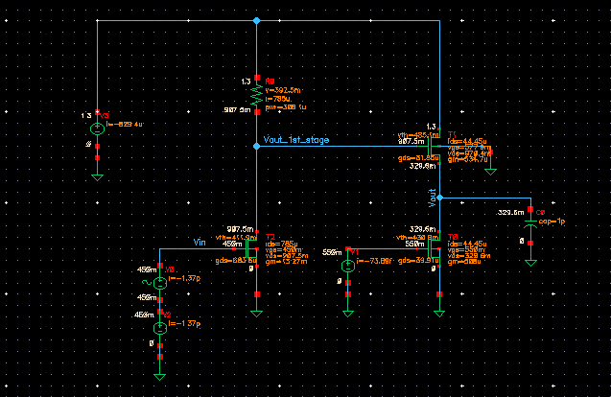
Fig.2. Schematic of the designed circuit with operating points

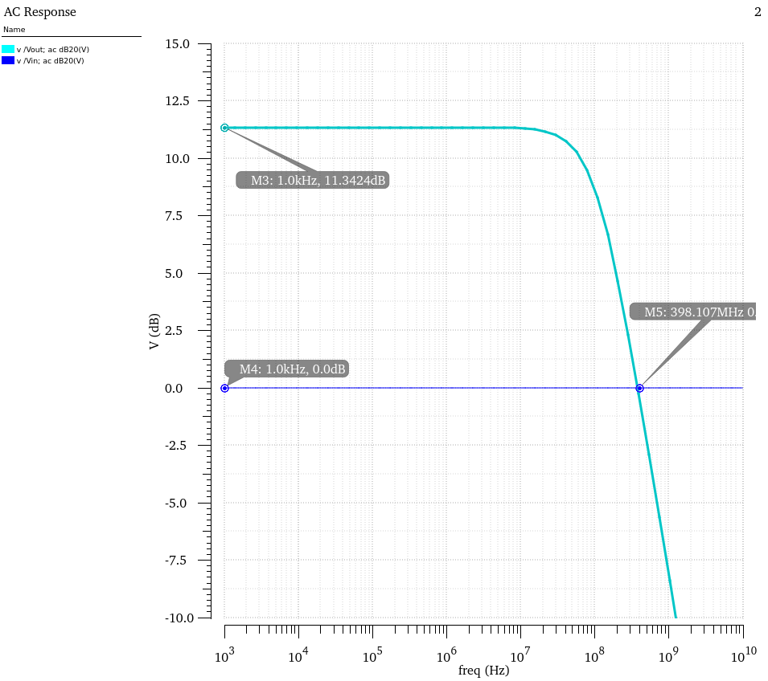
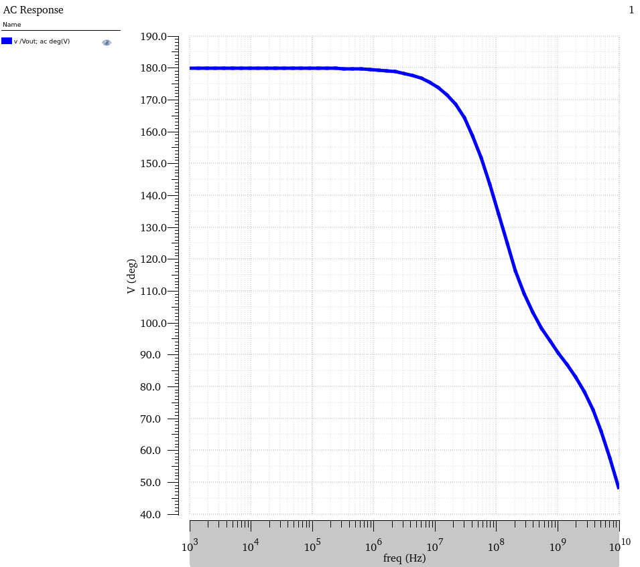
Fig.3. AC Response

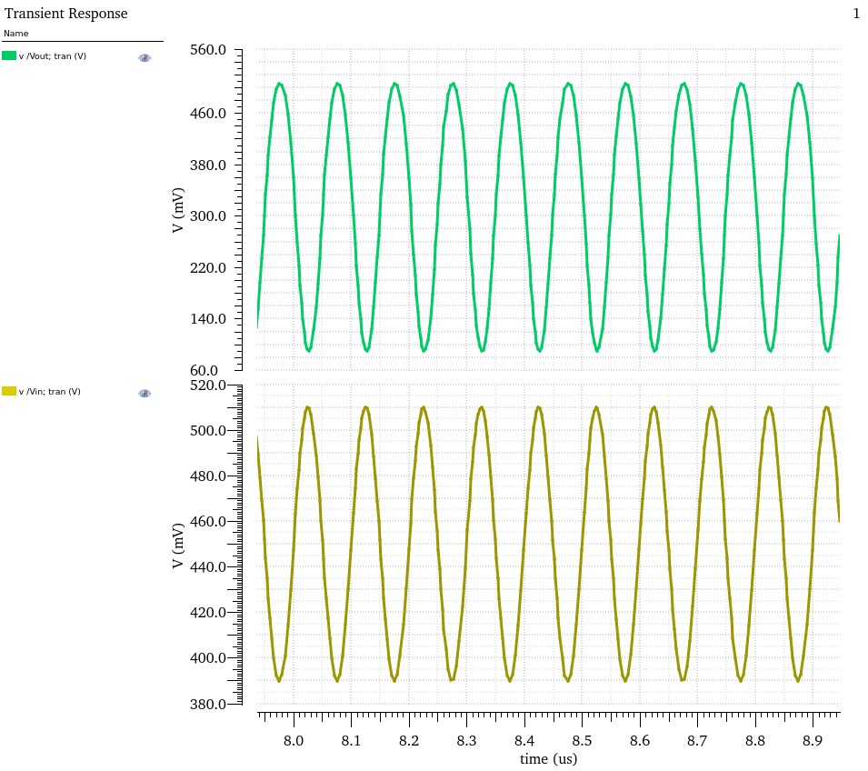
Fig.4. Transient Response

